Experiment 6
6. Demonstrate the creation and management of your digital identity.
- Create a social media profile (LinkedIn preferred).
- Add a profile photo, short bio, skills, and education details.
- Create a simple post about <My Learning Journey in Digital Literacy.=
- Change your privacy settings to:
a. Who can see your posts.
On LinkedIn, you can choose who sees your posts.
Options include:
- Anyone (Public) – All LinkedIn users + people outside LinkedIn
- Connections only – Only your LinkedIn connections
- Group members – If posting in a specific group
- Anyone + Twitter (if connected) To change:
Settings Visibility Visibility of your LinkedIn activity Who can see your posts b. Who can message you
You can control who is allowed to send you messages.
Options include:
- Everyone on LinkedIn
- Your connections only
- People who have your email • InMail only (Prem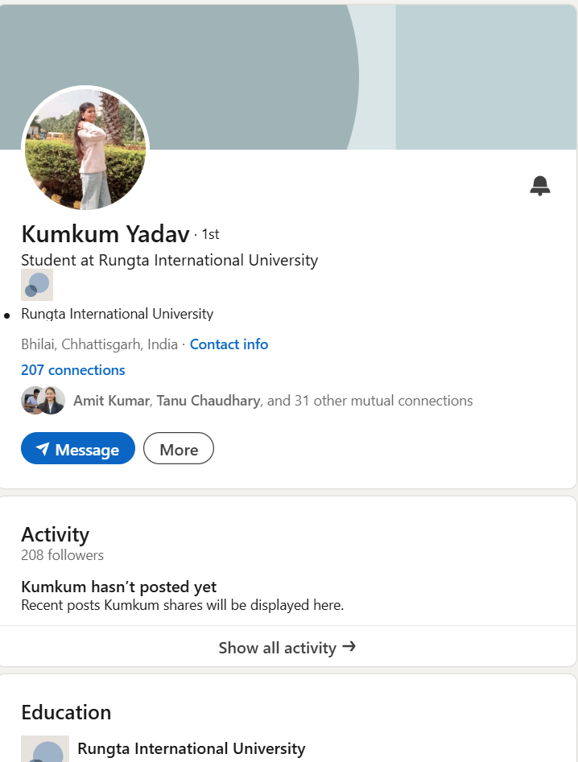ium feature) To change:
